**Exercise: Indicating business performance**

**Introduction**

Your manager, Adio, asks you to prepare a report for the sales team at Adventure Works displaying key performance indicators (KPIs). The stakeholders need your report to answer a variety of KPI-related questions, including:

* What are the total sales and average sales?
* What are the monthly total sales?
* What is the total number of orders placed during this time period?
* What is the total marketing expenditure, and what is the monthly marketing expenditure?
* What is the change in sales over time for the sales teams, and how does this correlate with marketing spending?
* What sales region had the highest sales during this time period, and how did their ranking change over time?
* What is the performance of different sales regions with their advertising campaigns?

To complete this task, your manager provides you with a sales dataset for the last three months containing total sales volume and advertising spending for various sales regions. Each of these regions runs different advertising campaigns.

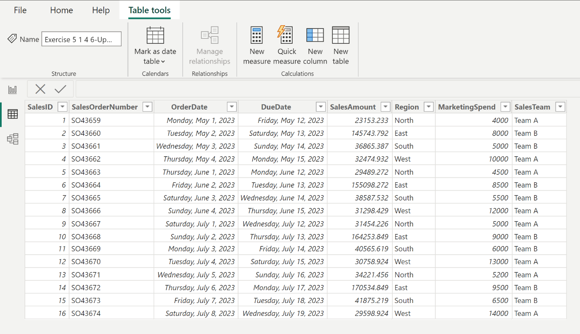

In this exercise, you’ll apply your knowledge of specialist visualizations, such as waterfall and ribbon charts, to create visualizations for the sales report that will convey the required insights

**Instructions**

**Step 1: Load the data**

Load the *Indicating business performance* dataset into Power BI Desktop.

[Indicating business performance](https://d3c33hcgiwev3.cloudfront.net/K6Vlty7AQRW78H63mRST5A_4f5b5c7a3aa84dcd84c89210434049e1_Indicating-business-performance.xlsx?Expires=1711324800&Signature=FqFiTL7fs8Z54kdhE4U7AO4HjEwtLAbp8DDxtuoxuRvcypRFLKM0CzsjVH6X4A09akUgtnUIpyLw7q2Nomc-Ttk3c5njlPpp9u~6RJUQnckjgZYpcSJ8EA6BIGZabcpp4GNPv9~pXX38GOr76nlmioysK~pNM43I0ku7f9ENcEY_&Key-Pair-Id=APKAJLTNE6QMUY6HBC5A" \t "_blank)

[XLSX File](https://d3c33hcgiwev3.cloudfront.net/K6Vlty7AQRW78H63mRST5A_4f5b5c7a3aa84dcd84c89210434049e1_Indicating-business-performance.xlsx?Expires=1711324800&Signature=FqFiTL7fs8Z54kdhE4U7AO4HjEwtLAbp8DDxtuoxuRvcypRFLKM0CzsjVH6X4A09akUgtnUIpyLw7q2Nomc-Ttk3c5njlPpp9u~6RJUQnckjgZYpcSJ8EA6BIGZabcpp4GNPv9~pXX38GOr76nlmioysK~pNM43I0ku7f9ENcEY_&Key-Pair-Id=APKAJLTNE6QMUY6HBC5A" \t "_blank)

**Step 2: Compute the metrics and create visualizations**

Based on the stakeholders’ needs, you identify the following as KPIs relevant to the sales teams:

* Total sales
* Average sales
* Total sales per month
* Total orders
* Total and monthly marketing spend
* Sales change over time for sales teams and in relation to marketing spend
* Highest sales region
* Sales ranking changes

Compute the key performance indicators (KPIs) for the sales data and represent them using the appropriate visualizations by completing the following steps:

1. Total sales and average sales

* Create a card visualization to compute the total sales using the **Sales Amount** data field.
* Create a card visualization to compute average sales using the **Sales Amount** data field. **Tip:** Make sure the **Fields** field is set to **Average**.

1. Total sales per month

* Create a multi-row card visualization to compute the total sales for each month using the **Order Date** and **Sales Amount** data fields.

1. Total orders

* Create a card visualization to compute the total number of orders using **the Sales ID** data field.

1. Total and monthly marketing spend:

* Create a card visualization to compute the total marketing spend using the **Marketing Spend** data field.
* Create a multi-row card visualization to compute the monthly marketing spend using the **Order Date** and **Marketing Spend** data fields.

1. Total marketing spend in relation to monthly marketing spend

* Create a waterfall chart to show how the sales have changed over time for the different sales teams and how this change correlates with the marketing spend. Use the **Sales Amount**, **Month**, and **Sales Team** data fields.
* **Tip:** Place the **Marketing Spend** data field into the **Tooltips** field well to gain insight into the correlation between marketing spend and sales changes.

1. Region performance and ranking:

* Create a ribbon chart to identify the region with the highest sales during this period and visualize how their ranking has changed over time using the **Sales Amount**, **Month**, and **Sales Region** data fields.
* **Tip:** Place the **Marketing Spend** and **Sales Team** data fields into the **Tooltips** field well to gain insight into the factors that influence sales performance in different regions, and how marketing strategies and teams contribute to the overall result.

**Step 3: Communicate results**

In a Word document, write a few sentences about each visualization, communicating the results of your analysis to support the stakeholders’ understanding. Ensure you address the sales team’s questions in your written report:

* What are the total sales and average sales?
* What are the monthly total sales?
* What is the total number of orders placed during this time period?
* What is the total marketing expenditure, and what is the monthly marketing expenditure?
* What is the change in sales over time for the sales teams, and how does this correlate with marketing spending?
* What sales region had the highest sales during this time period, and how did their ranking change over time?
* What is the performance of different sales regions with their advertising campaigns?

**Step 4: Save your work**

Save your report and analysis write-up for future use.

**Conclusion**

In this exercise, you consolidated your understanding of the significance and use of KPIs in a business context. You experienced ways of extracting meaningful insights from raw data by calculating and visualizing specific KPIs such as total sales, average sales, number of orders, and marketing expenditure. Additionally, you learned to relate different KPIs to each other to unearth deeper insights, for instance, how sales trends are affected by marketing spending, and had the opportunity to tackle anomalies in data, such as identifying regions where high marketing spend does not translate to high sales.

In a Word document, write a few sentences about each visualization, communicating the results of your analysis to support the stakeholders’ understanding. Ensure you address the sales team’s questions in your written report:

Answers

1.What are the total sales and average sales?

What are the monthly total sales?

What is the total number of orders placed during this time period?

What is the total marketing expenditure, and what is the monthly marketing expenditure?

What is the change in sales over time for the sales teams, and how does this correlate with marketing spending?

What sales region had the highest sales during this time period, and how did their ranking change over time?

East

What is the performance of different sales regions with their advertising campaigns?

**Exemplar: Indicating business performance**

**Introduction**

In the exercise, *Indicating business performance*, you put your knowledge of data visualization into practice by computing and creating KPI-related visualizations for Adventure Works’ sales team.

Your task in this exercise was to create a report showing KPIs that provided the sales team with insights into their performance in the last three months. In particular, your task was to create a report that answered various KPI-related questions:

* What are the total sales and average sales?
* What are the total sales across all regions?
* What is the total number of orders placed during this time period?
* What is the total marketing expenditure, and what is the monthly marketing expenditure?
* What is the change in sales over time for the sales teams, and how does this correlate with marketing spending?
* What sales region had the highest sales during this time period, and how did their ranking change over time?
* What is the performance of different sales regions with their advertising campaigns?

You were required to create card and multi-row card visualizations, as well as a waterfall and ribbon chart in Microsoft Power BI.

This reading provides you with a step-by-step guide for creating this report. It also includes screenshots that you can compare against your work.

**Instruction solutions**

**Step 1: Load the data**

1. Download the provided dataset to your computer.
2. Create a new Power BI project.
3. Import this dataset Excel file to your Power BI project.
4. In the preview window, ensure the data appears correct, and then select **Load** to import data without transforming anything.

**Step 2: Compute the KPI metrics and create visualizations**

Compute the key performance indicators (KPIs) for the sales data and represent them using the appropriate visualizations by completing the following steps:

1. Total sales and average sales

* For total sales, select the **Card** visualization from the **Visualizations** pane.
* Drag and drop **Sales Amount** into the **Values** field. This will automatically calculate the total sales.
* Create another Card visualization to represent average sales by selecting the **Card** visualization from the **Visualizations** pane.
* Drag and drop **Sales Amount** into the **Values** field.
* Select the **Fields** field and change **Sum** to **Average**. This calculates the average sales.

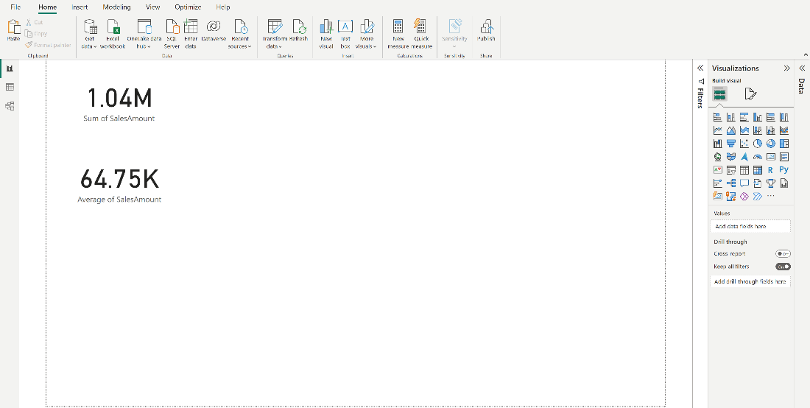

1. Total sales per month

* Select the **Multi-row card** visualization from the **Visualizations** pane.
* Drag and drop the **Sales Amount field** into the **Fields** well.
* Expand the **Order Date** field. Drag and drop the **Month** field into the **Fields** well.This will show the total sales for each month.

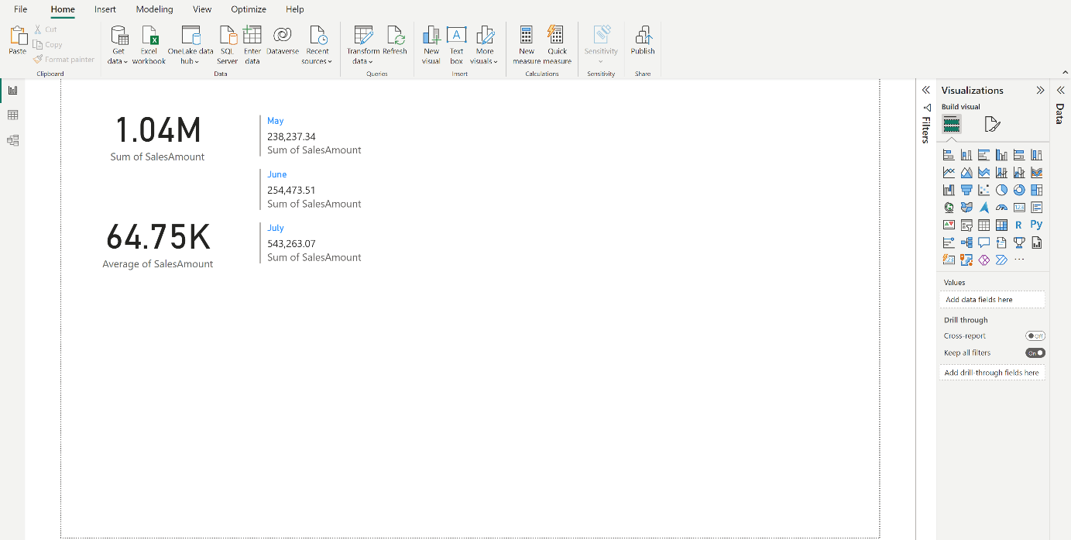

1. Total orders

* Select the **Card** visualization from the **Visualizations** pane.
* Drag and drop **Sales ID** into the **Fields** field. This will show the number of total sales during this time.

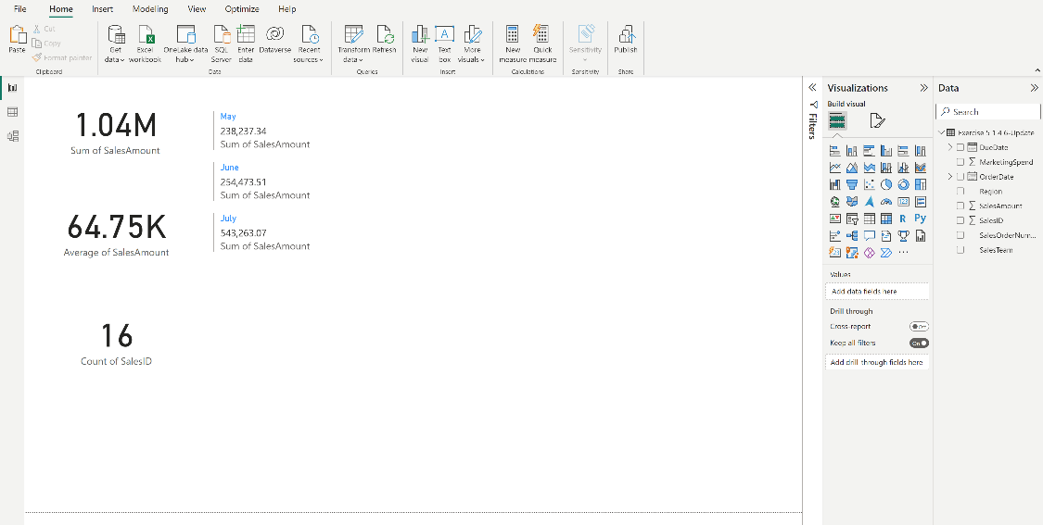

1. Total marketing spend and monthly marketing spend

* For total marketing spend, select the **Card** visualization from the **Visualizations** pane.
* Drag and drop **Marketing Spend** into the **Fields** field. This will show the sum of total marketing spend during this time.
* For monthly marketing spend, select the **Multi-row** card visualization from the **Visualizations** pane.
* Drag and drop the **Marketing Spend** into the **Fields** well.
* Expand the **Order Date** field. Drag and drop the **Month** field into the **Fields** well.This will show total marketing spend for each month.

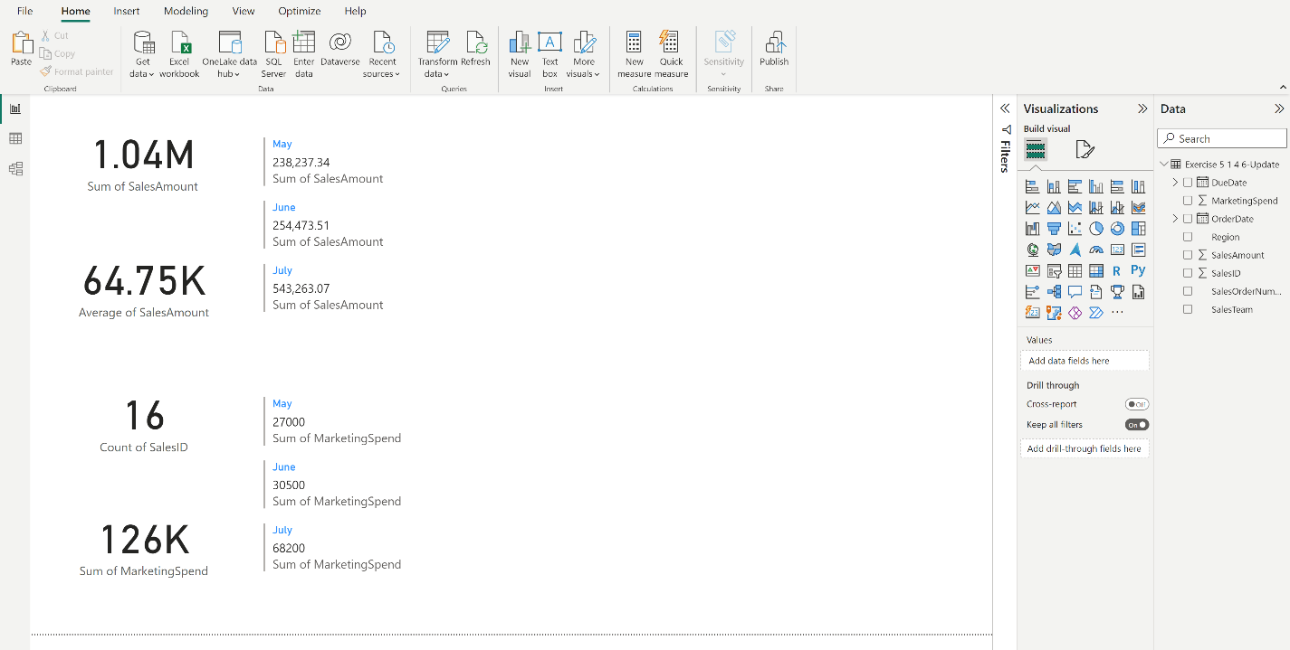

1. Total marketing spend in relation to monthly marketing spend

* Select the **Waterfall** chart from the **Visualizations** pane.
* Drag and drop **Sales Amount** into the **Y-axis** field and **Month** from **Order Date** into the **Category** field. This will display sales changes over the months.
* Drag and drop the **Sales Team** field into the **Breakdown** field.
* Drag and drop **Marketing Spend** into the **Tooltips** field to see its correlation with sales changes.
* Hover over each item to examine how the team did with their advertising budget compared to the previous month.

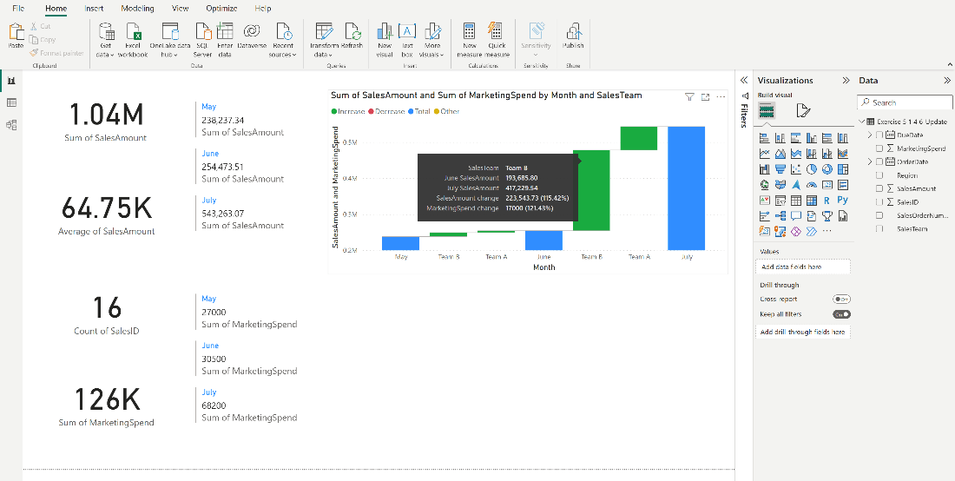

1. Region performance and ranking:

* Select the **Ribbon** chart from the **Visualizations** pane.
* Drag and drop **Sales Amount** field into the **Y-axis** well and **Month** from the **Order Date** field into the **X-Axis** well. This will display sales changes over the months.
* Drag and drop the **Region** field into the **Legend** well.
* Drag and drop **Marketing Spend** into the **Tooltips** field to see its value with sales changes.
* Hover the mouse to the region with the highest sales. For example, the tooltip displayed when hovering over this region tells you that it's the East region and values are for July.

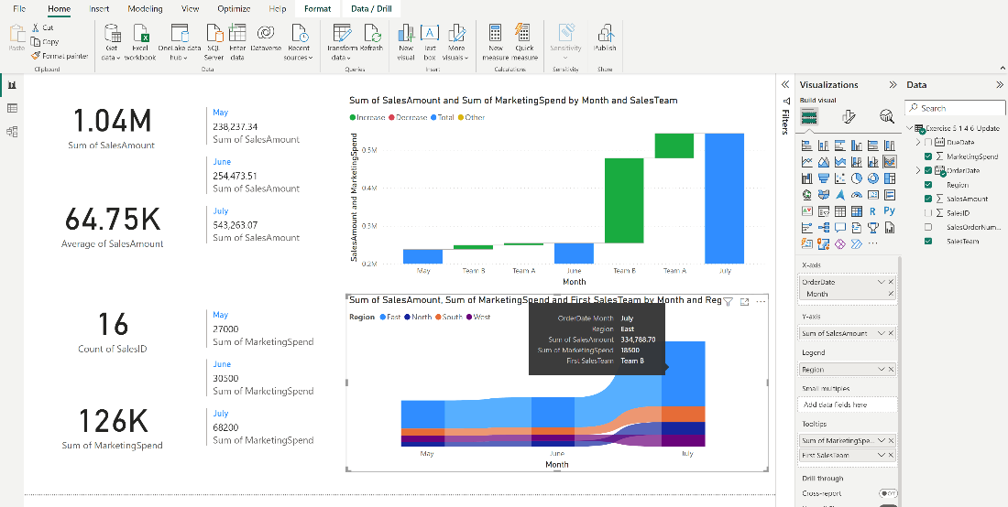

**Step 3: Communicate results**

Based on the analysis performed in Power BI, the following key insights and trends can be concluded:

* **Total and average sales**: The total sales for the business across all regions from January to March amount to approximately $1.04 million, with an average monthly sale of approximately $64.75K per order.
* **Sales across regions**: When looking at the regional breakdown from the ribbon chart, the East and South regions (Team B) have higher sales when compared to the North and West regions (Team A), indicating better overall performance.
* **Number of orders**: The total number of distinct orders placed during this period is around 16. This provides an insight into the volume of transactions that were processed.
* **Marketing expenditure:** The total marketing expenditure during this period amounts to about $126K. In a monthly breakdown, marketing spend has seen a consistent increase which aligns with the objective of driving up sales.
* **Sales and marketing expenditure relationship**: The waterfall chart indicates a positive correlation between sales and marketing spending. As the marketing expenditure increased, sales also grew. However, the ad campaigns run by Team B were more successful than Team A. An extra $17,000 spent on marketing brought approximately $223K of sales for Team B in July. On the other hand, an extra $20,000 marketing budget brought only $65K in sales for Team A in July.
* **Region performance and ranking**: The ribbon chart reveals that the East region consistently performed the best in terms of sales. However, even with substantial advertising spend, the West region did not perform proportionally well in sales, indicating potential issues with their advertising campaigns.

**Step 4: Save the report**

* Once you are satisfied with your report, save your work by going to the **File** menu and then selecting **Save**.

**Final output**

One example of the final sales report is suggested below:

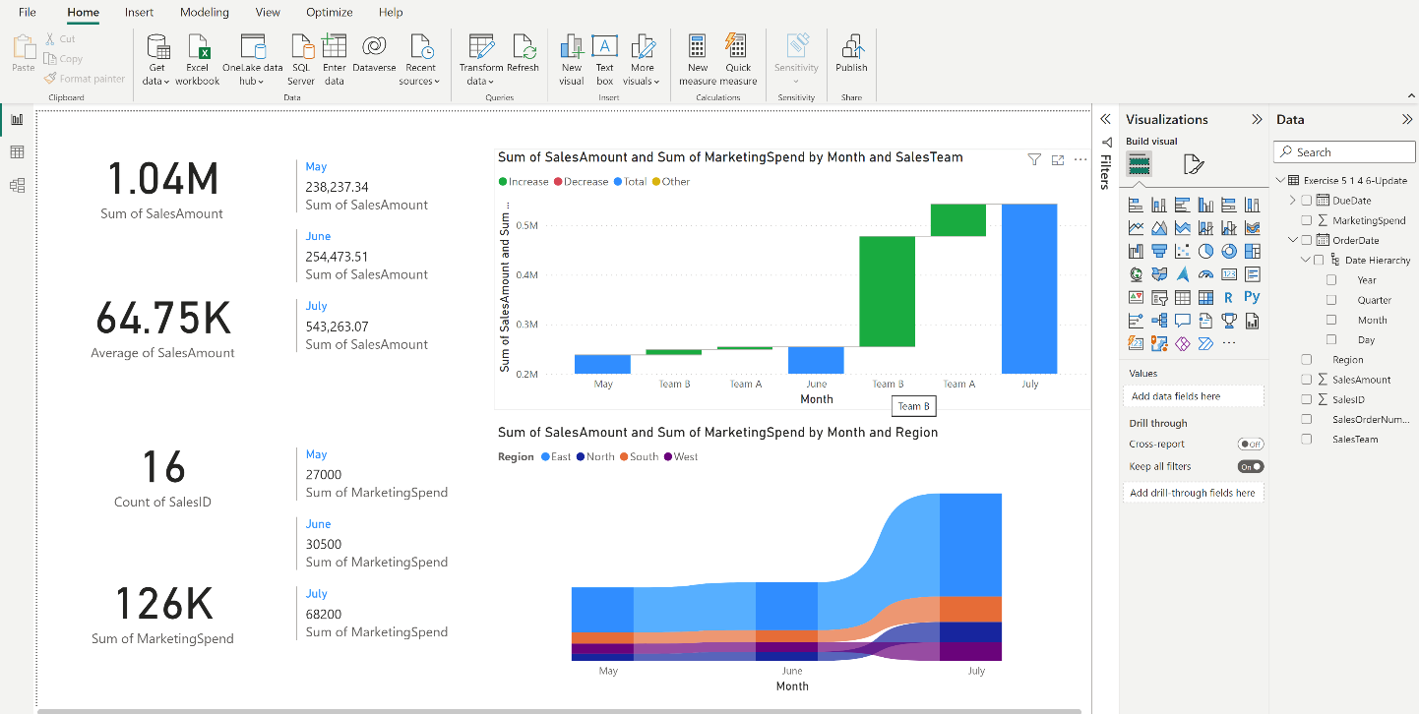

**Conclusion**

Through this exercise, you practiced leveraging Power BI's visualization tools to extract, analyze, and visualize significant insights. You successfully created KPI visualizations, such as total sales, average sales, and total orders using card and multi-row card visuals. The usage of waterfall and ribbon charts allowed you to track the changes in sales over time, understand how marketing expenses influence sales, and monitor the ranking changes of different sales regions. Your analysis revealed valuable insights for the sales team, like the powerful performance of the East and South regions (Team B) and potential inefficiencies in the West region's advertising campaigns.

